

**Loudoun County, Virginia**

**Performance Bond Release Certification**

Ms. Elisabeth Smith, Director

Loudoun County Building & Development

1 Harrison Street, S.E.

P.O. Box 7000 MSC #60

Leesburg, VA 20177-7000

703-777-0220

**Name of Applicant(s):** ____________________________________________________

____________________________________________________

**Address:** _______________________________________________________________

_______________________________________________________________

_______________________________________________________________

**Contact:** _______________________________________________________________

**Phone Number/Email Address:** ____________________________________________

**Owner/Lessee:**  __________________________________________________________

**Project Name:** __________________________________________________________

**Bond Number:** __________________________________________________________

**Application Number:** ____________________________________________________

**Application Approval Date:** _______________________________________________

**Is this application subject to proffers and/or special exception conditions?** Yes ___ No ___

If yes, please provide the Proffer/Condition Status Update Form.

**All bond release certifications must complete the Affidavit.**

If this application is subject to proffers and/or special exception conditions, please insert the Proffer/Condition Status Update Form from [Loudoun Land Applications and Comments](https://experience.arcgis.com/experience/766df83879dd4e77900e03cb2198ee98?data_id=dataSource_1-187950a974b-layer-5%3A3740823) (select search criteria and click “Apply,” click the application pin on the map, and click “View Plan in LandMARC”) or [LandMARC](https://loudouncountyvaeg.tylerhost.net/prod/SelfService#/map) (click the “Search” tab, enter application number, and click “Search”). If a form has not previously been completed, please download and complete a new [Proffer/Condition Status Update Form](https://www.loudoun.gov/DocumentCenter/View/49758/ProfferCondition-Status-Update-Form-DOC) to insert here.

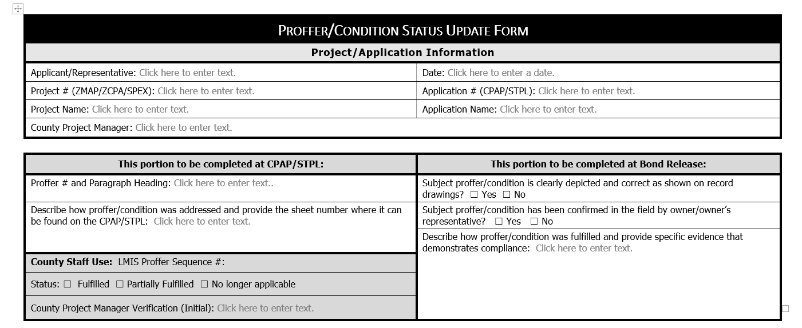

AFFIDAVIT

STATE OF VIRGINIA

COUNTY OF LOUDOUN, TO WIT:

I, _______________________________, being duly sworn, depose and say that I am Owner/Lessee of the property involved in this Performance Bond Release Certification. Furthermore, I do hereby certify, to the best of my knowledge, that all proffers and/or special exception conditions for this project are satisfied and complete, as per Loudoun County FSM 8.101.A.5.

If subject proffers and/or special exception conditions are found in the future to be incomplete, then said proffers and/or special exception conditions shall be deemed unsatisfied at that time. In this case, I hereby agree to perform any necessary work to satisfy these obligations as directed by Loudoun County.

Signature of Owner / Date: Mailing Address:

___________________________ ________________________

___________________________ ________________________

Phone #: ________________________

STATE OF VIRGINIA

COUNTY OF LOUDOUN, TO WIT:

I, the undersigned, a Notary Public of and for the County and State aforesaid, whose commission expires the ___ day of _____________, 20___, do hereby certify that _____________________, whose name is signed to the foregoing Performance Bond Release Certification, this day acknowledged the same before me in my County aforesaid.

Given under my hand and seal this ___ day of ____________________, 20___.

_______________________

Notary Public

My Commission Expires: ____________________

**REVIEWED/APPROVED BY:** __________________________________________________

Loudoun County Zoning Administrator Date